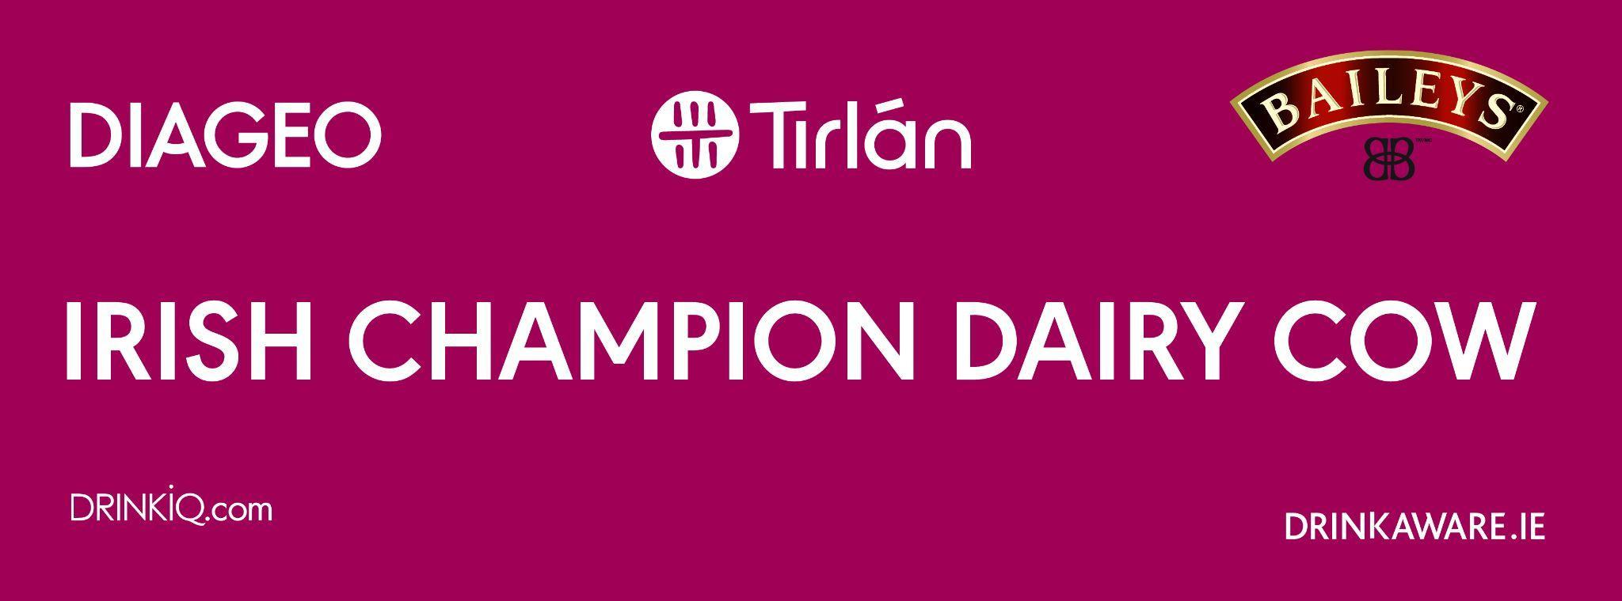

**Promotion/Giveaway Terms & Conditions**

**Promoter: MF Communication on behalf of Diageo Ireland Unlimited Company T/A Diageo Ireland (“Diageo”), St James’s Gate, Dublin 8, Ireland**

1. By participating in a Diageo Baileys Irish Champion Cow Facebook Promotion or Giveaway, you fully agree to Facebook terms & conditions https://www.facebook.com/legal/terms as well as the individual terms and conditions of the specific promotion.
2. Diageo Baileys Irish Champion Cow online promotions and giveaways are open to people aged 18 and over only, who are resident in the UK or the Republic of Ireland and excludes employees of Diageo plc and Tirlan, and its subsidiary companies and employees of other companies commercially involved in the promotion/prize draw and their associated, affiliated or subsidiary companies, their families, agents, or anyone else directly connected with the promotion/prize draw.
3. The closing date for entries to the 'Like & Share' Facebook promotion for 5 winners to each win [2] complimentary tickets to the Virginia Show on 20th August is 5.00pm 11th August 2025. The winners will be selected at random from a draw on [12thAugust 2025] from the entrants who have liked the page and shared the post publicly during the promotional period. No purchase necessary. Entries are only valid if the entry is completed correctly in accordance with the specific Terms and Conditions. There will be 5 winners.
4. Only one entry permitted per person for the promotion. The decision of who wins tickets is final and no correspondence will be entered into. Winners will be notified first through a private message on or before [12th August 2025].
5. In order to receive their prize, the winners are required to provide Diageo Baileys Irish Champion Cow with their full name and postal address. Winners must be able to attend the Virginia Show on 20th August 2025 and all prizes are non-refundable and non-transferable. No cash alternative will be offered for any prizes.
6. Failure to acknowledge receipt of their win, or provide full name and address, within 24 hours of receiving notice from Diageo Baileys Irish Champion Cow promoter will invalidate the winner and an alternative winner may be selected by the same process as set out above.
7. Diageo Baileys Irish Champion Cow and/or Diageo will not be liable for any delays in the receipt of entries and Diageo Baileys Irish Champion Cow and/or Diageo do not accept responsibility for prizes which are not received or delivered. Diageo and their agents accept no responsibility for entries that are not received for any reason or difficulties experienced in submitting an entry to this Promotion and proof of submission will not be accepted as proof of delivery.
8. In the event that Diageo Baileys Irish Champion Cow and/or Diageo believes that an entry contravenes these Terms and Conditions, it reserves all rights to delete the entry at its absolute and sole discretion.
9. We reserve the right to cancel or amend the Promotion or the Rules without notice in the event of a catastrophe, war, civil or military disturbance, act of God or any actual or anticipated breach of any applicable law or regulation or any other event outside our control. Any changes will be posted either within these terms and conditions or the Promotion Notice.
10. With the exception of the entry tickets to the Virginia Show, all taxes, insurances, travel & transfers, spending money and other expenses (including meals or personal expenses etc.) as the case may be are the sole responsibility of the prize winner.
11. Your entry and any information submitted by you must be personal to and relate specifically to you. You hereby warrant that your Entry and all information which you submit and/or distribute will not infringe the intellectual property, privacy or any other rights of any third party, and will not contain anything which is libellous, defamatory, obscene, indecent, harassing or threatening. If relevant, Diageo and its agents reserve the right, but not the obligation, to screen, filter and/or monitor information provided by you and to edit, refuse to distribute or remove the same.
12. Diageo and/or its agents cannot accept any responsibility for any damage, loss, injury or disappointment suffered by any entrant entering the Promotion or as a result of accepting any prize.
13. Diageo and/or its agents are not responsible for any problems or technical malfunction of any telephone network or lines, computer online systems, servers, or providers, computer equipment or software, failure of any email or entry to be received on account of technical problems or traffic congestion on the Internet, telephone lines or at any web site, or any combination thereof, including any injury or damage to entrant's or any other person's computer or mobile telephone related to or resulting from participation in the Promotion.
14. Winners may be requested to take part in promotional activity and Diageo and its agents reserve the right to use the names and addresses of winners in any publicity both in paper and online if permission is granted by the winner.
15. The Promoter will use your personal information only in accordance with these terms and conditions and our privacy policy which can be found at <https://footer.diageohorizon.com/dfs/assets/www.diageo.com/PrivacyPolicy_en.html?locale=en-gb>. The Promoter will only use your personal information for the purpose of carrying out the Promotion. Where the Promoter is not responsible for the fulfilment of or delivery of the prize, the Promoter shall share your personal information with named associates, Rohan Whelan & Rebecca McConnell,who are responsible for the fulfilment of and delivery of the prize.

Subject to paragraph 15 and without prejudice to the Promoter's data protection obligations under relevant law, the Promoter shall make available, upon receipt of a written request Email [support@mfcommunication.net](mailto:support@mfcommunication.net), the winner's surname and county, and (if applicable) the winning entry.

1. Entrants to the Promotion can, at any time (including at or before the time of entry), object to all or some of their personal information being made available by writing to [support@mfcommunication.net](mailto:support@mfcommunication.net) However, the Promoter shall provide the information set out in paragraph 16 upon request from such competent authorities (including the Advertising Standards Authority in Ireland and/or the UK).
2. While nothing in these terms and conditions will limit the Promoter’s liability for death or personal injury caused by its negligence or for fraud, the Promoter will not be legally responsible to entrants or winners for any losses that were not foreseeable to the Promoter or to the entrant at the time of entry to the Promotion or which are caused by a third party.
3. Where the site and/or the Interactive Services are accessed from the Republic of Ireland or the UK this Agreement and the Promotion shall be governed by the laws of Northern Ireland and you hereby submit to the exclusive jurisdiction of the courts of Northern Ireland.
4. Entrants are deemed to have accepted these terms and conditions by participating in this Promotion.

Ends.